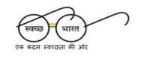
GOVT. MIZORAM LAW COLLEGE
Luangmual, Aizawl, Mizoram-796009
Tel.No.0389-2330363(P), 2332055(O)
Email: m_law_c@yahoo.com

(Affiliated to Mizoram University & Bar Council of India)
website: mlc.mizoram.gov.in

